**Swift Sets**

A set is a collection of unique data. That is, elements of a set cannot be duplicate. For example,

Suppose we want to store information about **student IDs**. Since **student IDs** cannot be duplicate, we can use a set.

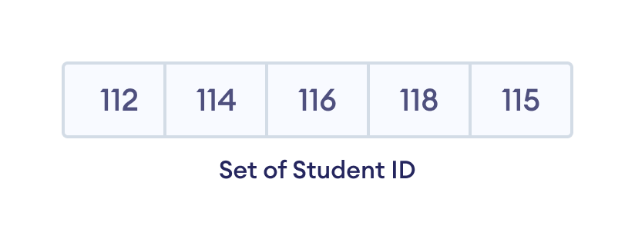

// create a set of integer type

var studentID : Set = [112, 114, 116, 118, 115]

Add Elements to a Set

We use the insert() method to add the specified element to a set. For example,

**var numbers: Set = [21, 34, 54, 12]**

**// using insert method**

**numbers.insert(32)**

**adds to end uf numbers set**

## **[21,34,54,12,32]**

## Create an Empty Set

In Swift, we can also create an empty set. For example,

## **var emptySet = Set<Int>()**

## **print("Set:", emptySet)** Remove an Element from a Set

We use the remove() method to remove the specified element from a set. For example,

**var languages: Set = ["Swift", "Java", "Python"]**

**print("Initial Set: \(languages)")**

**// remove Java from a set**

**let removedValue = languages.remove("Java")**

**print("Set after remove(): \(languages)")**

**OUTPUT:**

**Initial set was : ["Swift", "Java", "Python"]**

**After remove: = ["Swift", "Python"]**

Similarly, we can also use

* removeFirst() - to remove the first element of a set
* removeAll() - to remove all elements of a set

### 1. Union of Two Sets

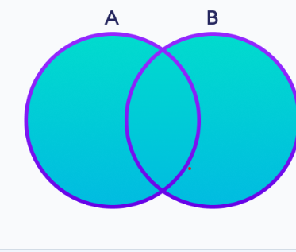We use the union() method to perform the set union operation. For example,

**// first set**

**let setA: Set = [1, 3, 5]**

**// second set**

**let setB: Set = [0, 2, 4]**

**// perform union operation**

**print("Union: ", setA.union(setB))  
  
output:**

**Union: [0,5,2,4,1,3]**

### 2. Intersection between Two Sets

The intersection of two sets **A** and **B** include the common elements between set **A** and **B**.

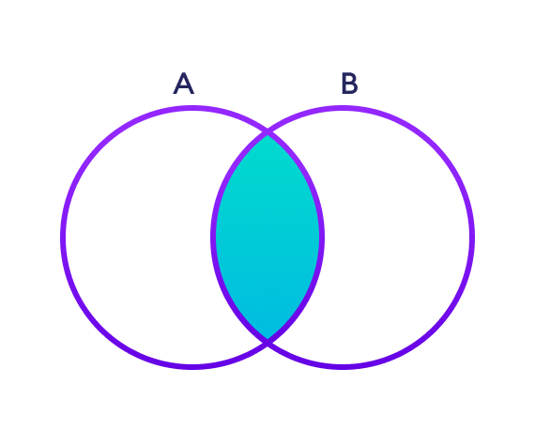

**// first set**

**let setA: Set = [1, 3, 5]**

**print("Set A: ", setA)**

**// second set**

**let setB: Set = [1, 2, 3]**

**print("Set B: ", setB)**

**// perform intersection operation**

**print("Intersection: ", setA.intersection(setB))**

Intersection: [3, 1]

### 3. Difference between Two Sets

The difference between two sets **A** and **B** include elements of set **A** that are not present on set **B**.

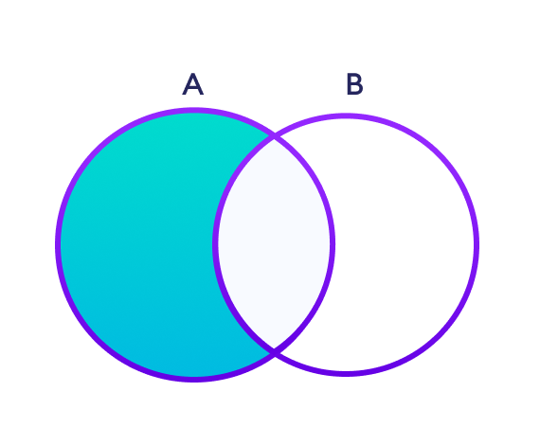

We use the subtracting() method to perform the difference between two sets. For example,

**// first set**

**let setA: Set = [2, 3, 5]**

**print("Set A: ", setA)**

**// second set**

**let setB: Set = [1, 2, 6]**

**print("Set B: ", setB)**

**// perform subtraction operation**

**print("Subtraction: ", setA.subtracting(setB))**

Set A: [3, 5, 2]

Set B: [1, 6, 2]

Subtraction: [3, 5]

### 4. Symmetric Difference between Two Sets

The symmetric difference between two sets **A** and **B** includes all elements of **A** and **B** without the common elements.

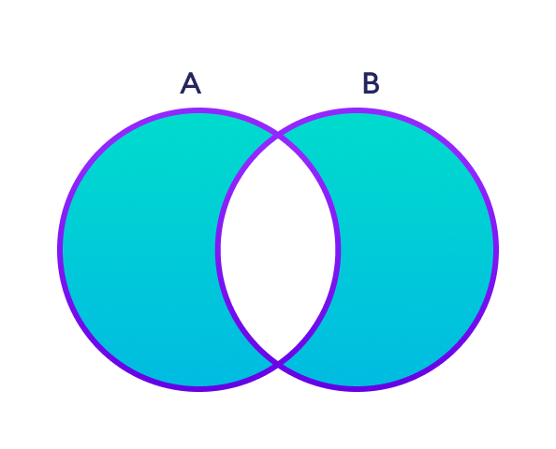

We use the symmetricDifference() method to perform symmetric difference between two sets. For example,

**// first set**

**let setA: Set = [2, 3, 5]**

**print("Set A: ", setA)**

**// second set**

**let setB: Set = [1, 2, 6]**

**print("Set B: ", setB)**

**// perform symmetric difference operation**

**print("Symmetric Difference: ", setA.symmetricDifference(setB))**Set A: [5, 2, 3]

Set B: [2, 6, 1]

Symmetric Difference: [1, 6, 3, 5]

### 5. Check Subset of a Set

Set **B** is said to be the subset of set **A** if all elements of **B** are also present in **A**.

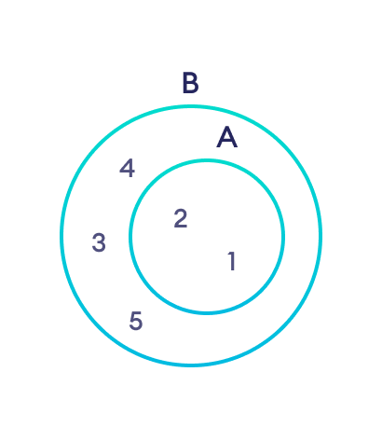We use the Subset() method to check if one set is a subset of another or not. For example,  
  
**// first set**

**let setA: Set = [1, 2, 3, 5, 4]**

**print("Set A: ", setA)**

**// second set**

**let setB: Set = [1, 2]**

**print("Set B: ", setB)**

**// check if setB is subset of setA or not**

**print("Subset: ", setB.isSubset(of: setA))**Set A: [3, 1, 2, 5]

Set B: [1, 2]

Subset: true